EXP.NO: 4
Create a web form that accepts a user’s name and
age. Write a Servlet to process the form data and
display it back on the browser.
AIM:
To create a simple web application that includes a form to accept a user’s name and age,
then use a Servlet to process the submitted data. The Servlet will retrieve the form data,
process it, and display the values back on the browser.

ALGORITHM:
1. Input:
• The user fills out a web form with their name and age and submits it.
2. Form Handling and Servlet Processing:
1. Create the Web Form:
o Create an HTML form with two input fields: one for the user&#39;s name and one
for the user&#39;s age.
o Add a submit button to the form.
o Set the form&#39;s action attribute to the URL of the Servlet and the method to
POST (or GET).
2. Create the Servlet Class:
o Write a Servlet that processes the form data submitted by the user.
o The Servlet will override the doPost() (or doGet() depending on the form
method) to handle form submissions.
o The Servlet will retrieve the name and age parameters from the request
object using request.getParameter(&quot;name&quot;) and request.getParameter(&quot;age&quot;).

3. Process the Data in the Servlet:
o Extract the name and age values submitted from the form.
o Validate the input (e.g., check if the age is a valid number).
o Prepare a response that will display the user&#39;s name and age back on the
browser.

4. Send Response to the Browser:
o The Servlet will send a response to the browser containing a message like:
▪ &quot;Hello, [name]! You are [age] years old.&quot;
o The response will be displayed to the user in the browser.
5. Deploy the Servlet:
o Compile the Servlet and deploy it to a Servlet container (like Apache
Tomcat).
o Ensure the web.xml file or Servlet annotations are used to map the Servlet to
the URL defined in the form&#39;s action attribute.

6. Test the Application:
o Open the web browser, fill in the form with the name and age, and submit it.
o The Servlet will process the data and display the message back to the user in
the browser.
CODE:
Index.html:
!DOCTYPE html>
<html>
<head>
<title>News Portal Registration</title>

<style>
body{
font-family: Arial;
background:#f2f2f2;
text-align:center;
}

.header{
background:#d40000;
color:white;
padding:20px;
font-size:30px;
}

.container{
margin-top:50px;
background:white;
width:400px;
padding:30px;
margin-left:auto;
margin-right:auto;
border-radius:10px;
box-shadow:0px 0px 10px gray;
}

input{
width:90%;
padding:10px;
margin:10px;
}

button{
background:#d40000;
color:white;
padding:10px 20px;
border:none;
font-size:16px;
cursor:pointer;
}

button:hover{
background:#900000;
}
</style>

</head>

<body>

<div class="header">
MiniTimes India
</div>

<div class="container">

<h2>Subscribe for Daily News</h2>

<form action="user" method="post">

<input type="text" name="name" placeholder="Enter Your Name" required>

<input type="number" name="age" placeholder="Enter Your Age" required>

<br>

<button type="submit">Subscribe</button>

</form>

</div>

</body>
</html>
Frameservlet.java
package com.example;

import java.io.IOException;
import java.io.PrintWriter;

import jakarta.servlet.ServletException;
import jakarta.servlet.annotation.WebServlet;
import jakarta.servlet.http.*;

@WebServlet("/user")
public class UserServlet extends HttpServlet {

protected void doPost(HttpServletRequest request, HttpServletResponse response)
throws ServletException, IOException {

String name = request.getParameter("name");
String age = request.getParameter("age");

response.setContentType("text/html");

PrintWriter out = response.getWriter();

out.println("<html>");
out.println("<body style='font-"
+ "family:Arial;text-align:center;'>");

out.println("<h1 style='color:red;'>MiniTimes India</h1>");

out.println("<h2>Hello " + name + "!</h2>");
out.println("<h3>You are " + age + " years old.</h3>");

out.println("<p>Thank you for subscribing to our daily news updates.</p>");

out.println("<h3>Top News Today</h3>");
out.println("<p>AI is transforming industries worldwide.</p>");
out.println("<p>New technology innovations announced today.</p>");
out.println("<br><br>");
out.println("<a href='form.html'><button style='padding:10px 20px;font-size:16px;'>Go Back to Login Page</button></a>");

out.println("</body>");
out.println("</html>");
}

OUTPUT:
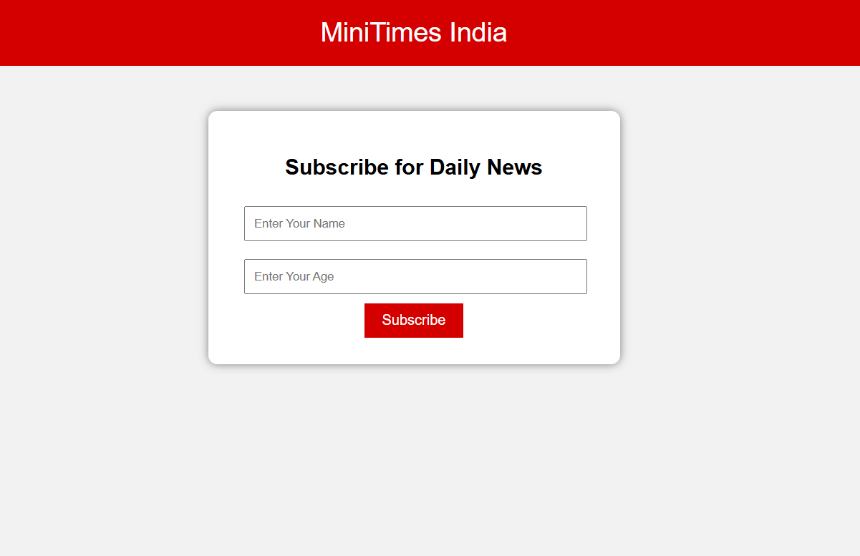

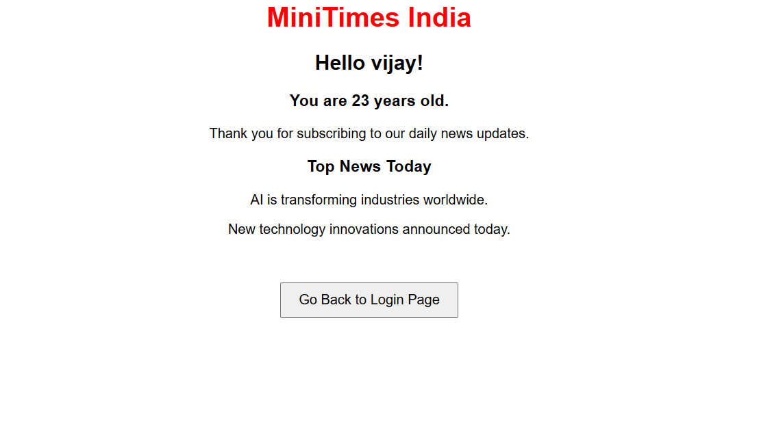

Result:
Html Page is created with embedded Bangalore map along with hot spot, frames ,map & Links.

